Explanation

In this scene, there are two barrels with nearly identical materials. The only difference between them, which prevents the combiner from working, is the ‘Metallic’ parameter of the shader.

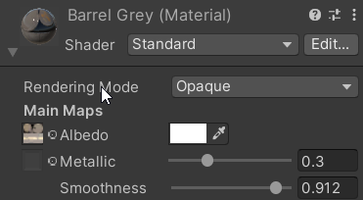
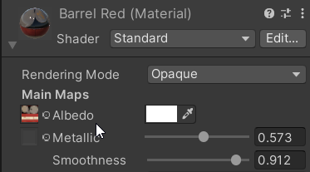

To combine materials that have different parameters, we need to adjust the Shader Properties.
- Create a Materials Combiner – Tools -> NGSTools -> Super Level Optimizer 2 -> Materials Combiner.
- In the Selection Tool, select Add Automatic to automatically include the barrels.
- If you press Combine now, nothing will happen because of the differing Metallic values.
- To fix this, you need to configure the Shader Properties.
- Go to Shader Properties Edit -> Edit Shader Properties.
- Set the Metallic parameter to Ignore (as shown in Image 3), or define a Threshold value to allow slight differences (e.g., if the difference in Metallic values is within the threshold, the materials can still combine).
- Press Combine.
